1. Frontend (Node.js with Express):
- Create a frontend using Express and Node.js.
- Include a form similar to the one from the Flask Assignment 2.
- Configure the form to send a request to the Flask backend.
- Backend (Flask):
- Use the Flask backend to handle the form submission and process the data.
- Folder Structure:
- Organize the project with separate folders for the frontend and backend.
- Docker Configuration:
- Create a Dockerfile for both the frontend and backend.
- Write a .yaml file (Docker Compose) to connect both services in the same network.
- Upload both images to docker hub and push your whole code to github and add the node_modules and other non required files(.vscode) in .gitignore
Answer:-

In this Docker assignment, I will make a Form submission page with a frontend and backend. The stacks in use are:-
For frontend:- Express and Node.js
For backend:- Flask, Python, Flask-cors

The steps are as follows:
- Created a frontend form submission page using Express and Node.js.
- Frontend port is exposed on 3000.
- The Form contains a name, email address and message sections with the submit button.
- Apart from this, I will add a ‘Docker’ file and ‘.dockerignore’ file too for the frontend.
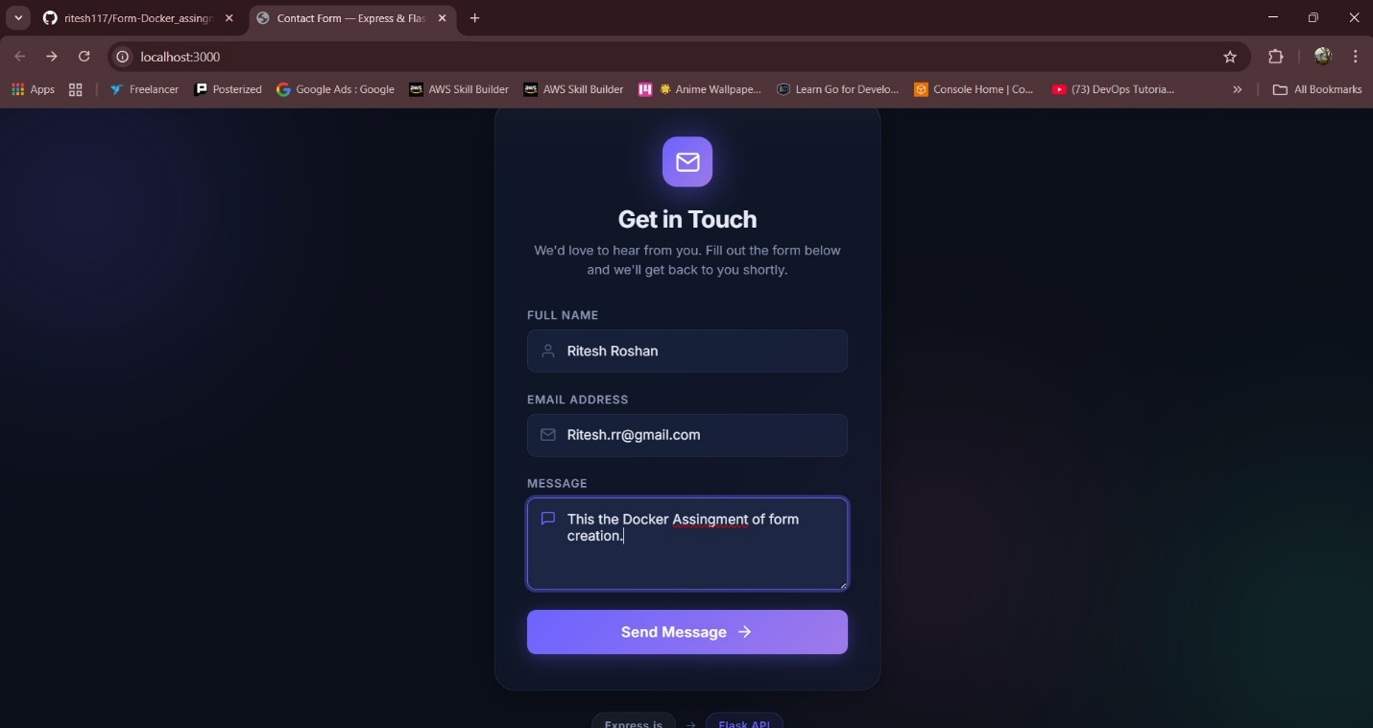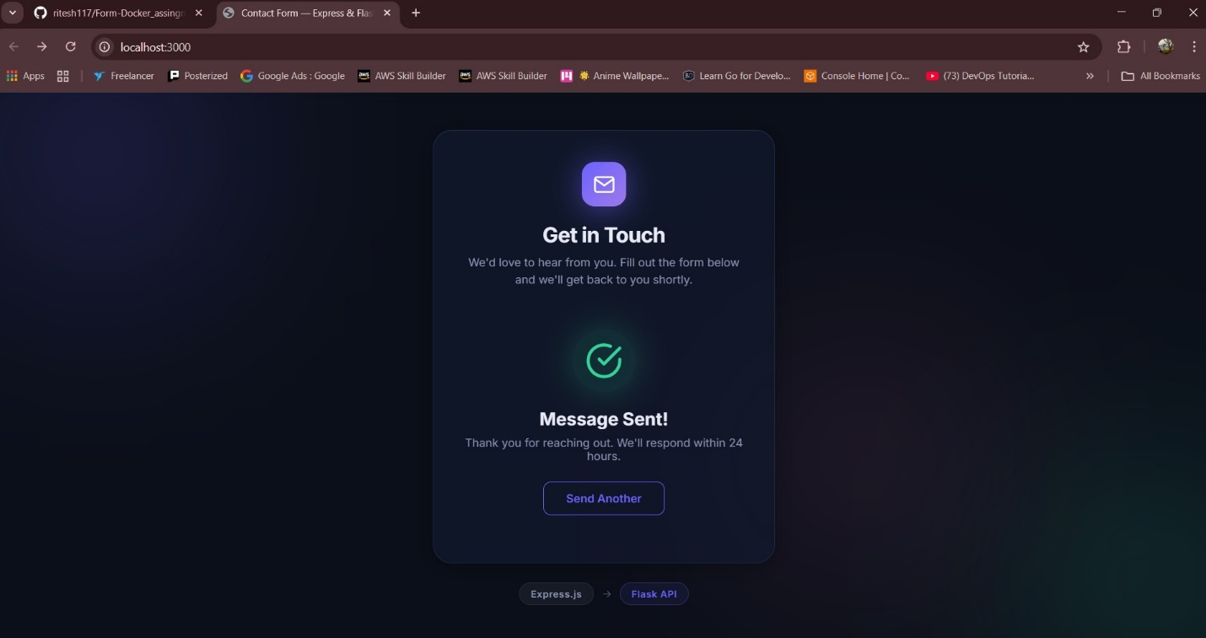
- Now, the backend is created with Flask and Python in which the ports are visible on 5000. There are 3 endpoints which I used are
- GET – ‘ / ‘ Health check
- POST – ‘ /submit ‘ Submit form data (JSON)
- GET – ‘ /submissions’ List all the submissions (debug)

- These Endpoints will show the data that was filled by the users from the form submission page. Apart from this, I will add a ‘Docker’ file and ‘.dockerignore’ file too for the backend.

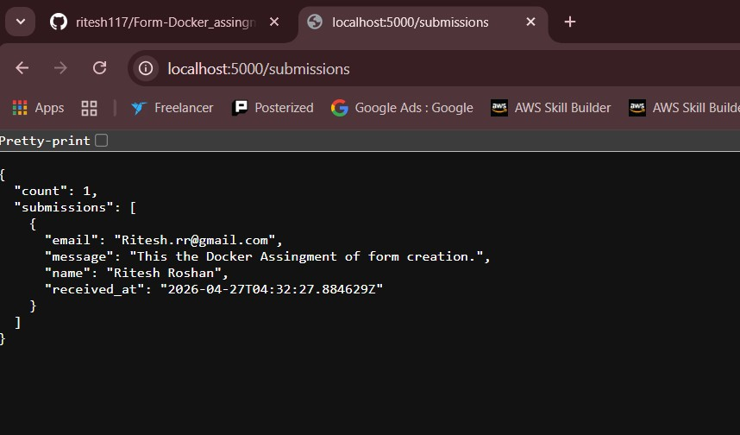

- As of now, my frontend and backend are completed. I can move to the next part where I have to push the code to the Github. But before pushing the code I have to make a ‘.gitignore’ file in which I will add the unreuired files which should not be uploaded to the Github( which is actually good practice).Here are the list of files I added in the ‘.gitignore’ file:-
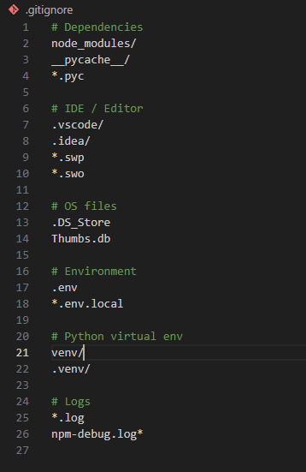

- So, I have added the unrequired file in the ‘.gitignore’ file. I can now push the code to GitHub. So to do so, I’ll create a git repository by the name of ‘Form-Docker_assignment’ and push the code in that repository.
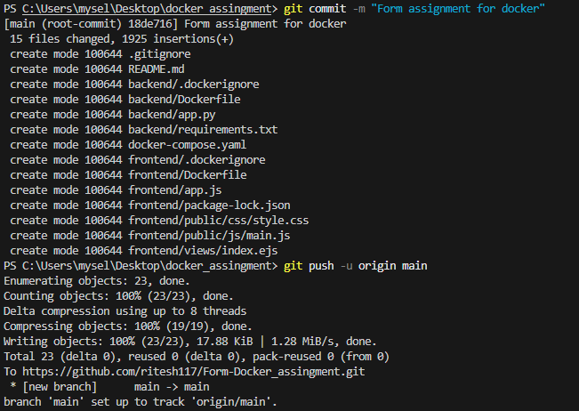

- So the code is pushed on GitHub now, I’ll Dockerize the frontend and backend but before doing so, I’ll make a “docker-compose.yaml” file in which I’ll do the port mapping so that the form should work on the same link.
- Docker Compose file contains the following details:-
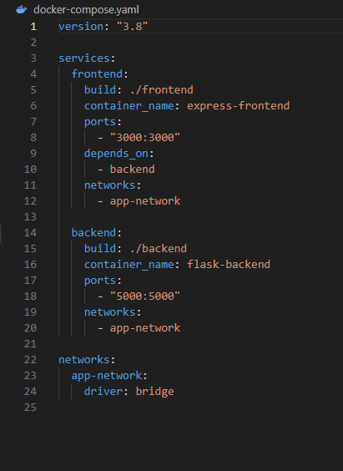

- Now, I have all the required files and settings done. I’ll now proceed to build the Docker images for both frontend and backend by using the command “docker-compose up –build”. As this command will build the Docker images and start the container which has both the images of frontend and backend at the same time, after the completion of the image build command.
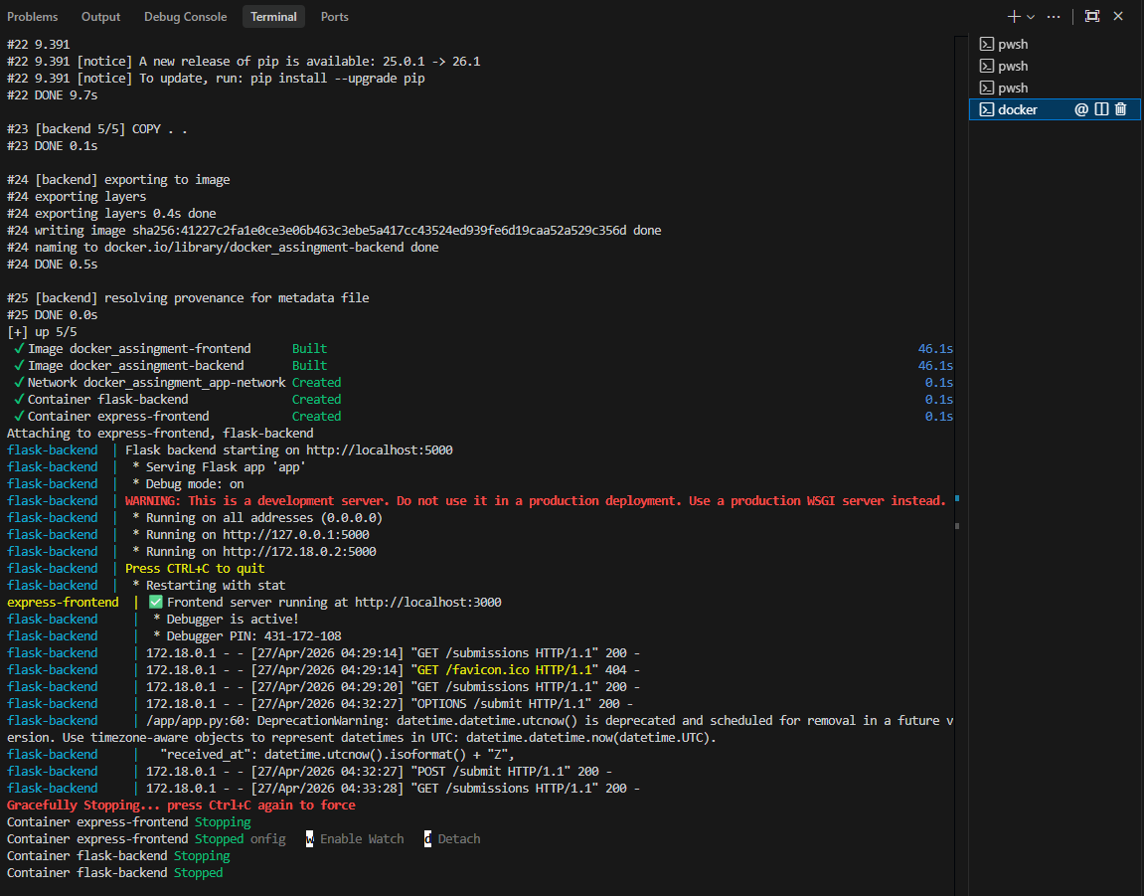
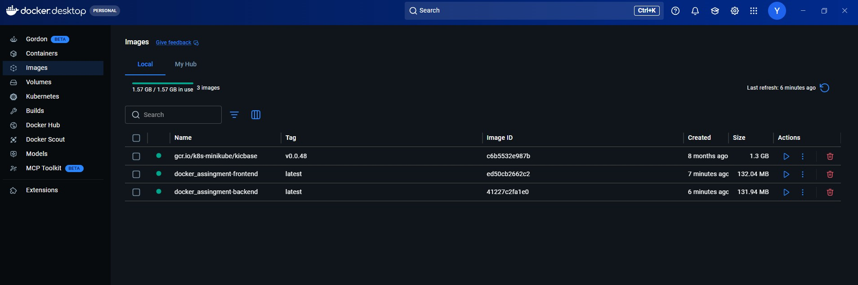
- As the Docker images are created and are working fine. And the form page is also responding perfectly!!!

GITHUB LINK:- https://github.com/ritesh117/Form-Docker_assingment.git

Submission Guidelines -: Share your github repo link

